

25 February 2021

DESCRIPTION: TENDER FOR APPOINTMENT OF A PANEL FOR GENERAL SUPPLY OF HYGIENE EQUIPMENT, CLEANING CONSUMABLES AND PEST CONTROL TO NYDA BRANCHES AND DISTRICT OFFICES FOR A PERIOD OF THIRTY-SIX MONTHS (36 MONTHS)

TENDER NUMBER: NYDA 2019/01/PDD

The National Youth Development Agency is hereby extending the validity period of the above bids to the 31 March 2021.

The validity period of the bid is therefore extended to allow the Agency to finalise the evaluation, adjudication, and appointment of the suppliers.

NB: This is not an extension of the closing date rather an extension of validity period.

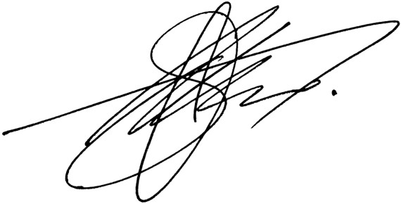
Mr. S. Mthombeni
Acting Manager: Supply Chain Management

